[ Insert official UPAEP logo ]
UPAEP · Decanato de Ingenierías
EVIDENCE — US11-T7
Test alert generation
SmartGreenAI: Cilantro Crop

1. Task information
Task ID | US11-T7
User Story | US-11 — Receive threshold alerts
Sprint | Sprint 3 (2026-10-12 – 2026-10-30)
Week | Week 3
Responsible | Jorge Velez Delgado
Peer reviewer | Alexis Enrique Valle Parra
Planned / actual hours | 1 h / 1 h
Completed on | October 29, 2026
Status | Done

2. Task description
Execute the cases: value below min, value above max, value in range, repeated out-of-range values (no duplicate) and return to range (resolved).

3. Completion conditions
✓ Condition 1: The five cases were executed.
How it was verified: The five cases were executed against the running system: below min, above max, in range, repeated out-of-range and return to range.
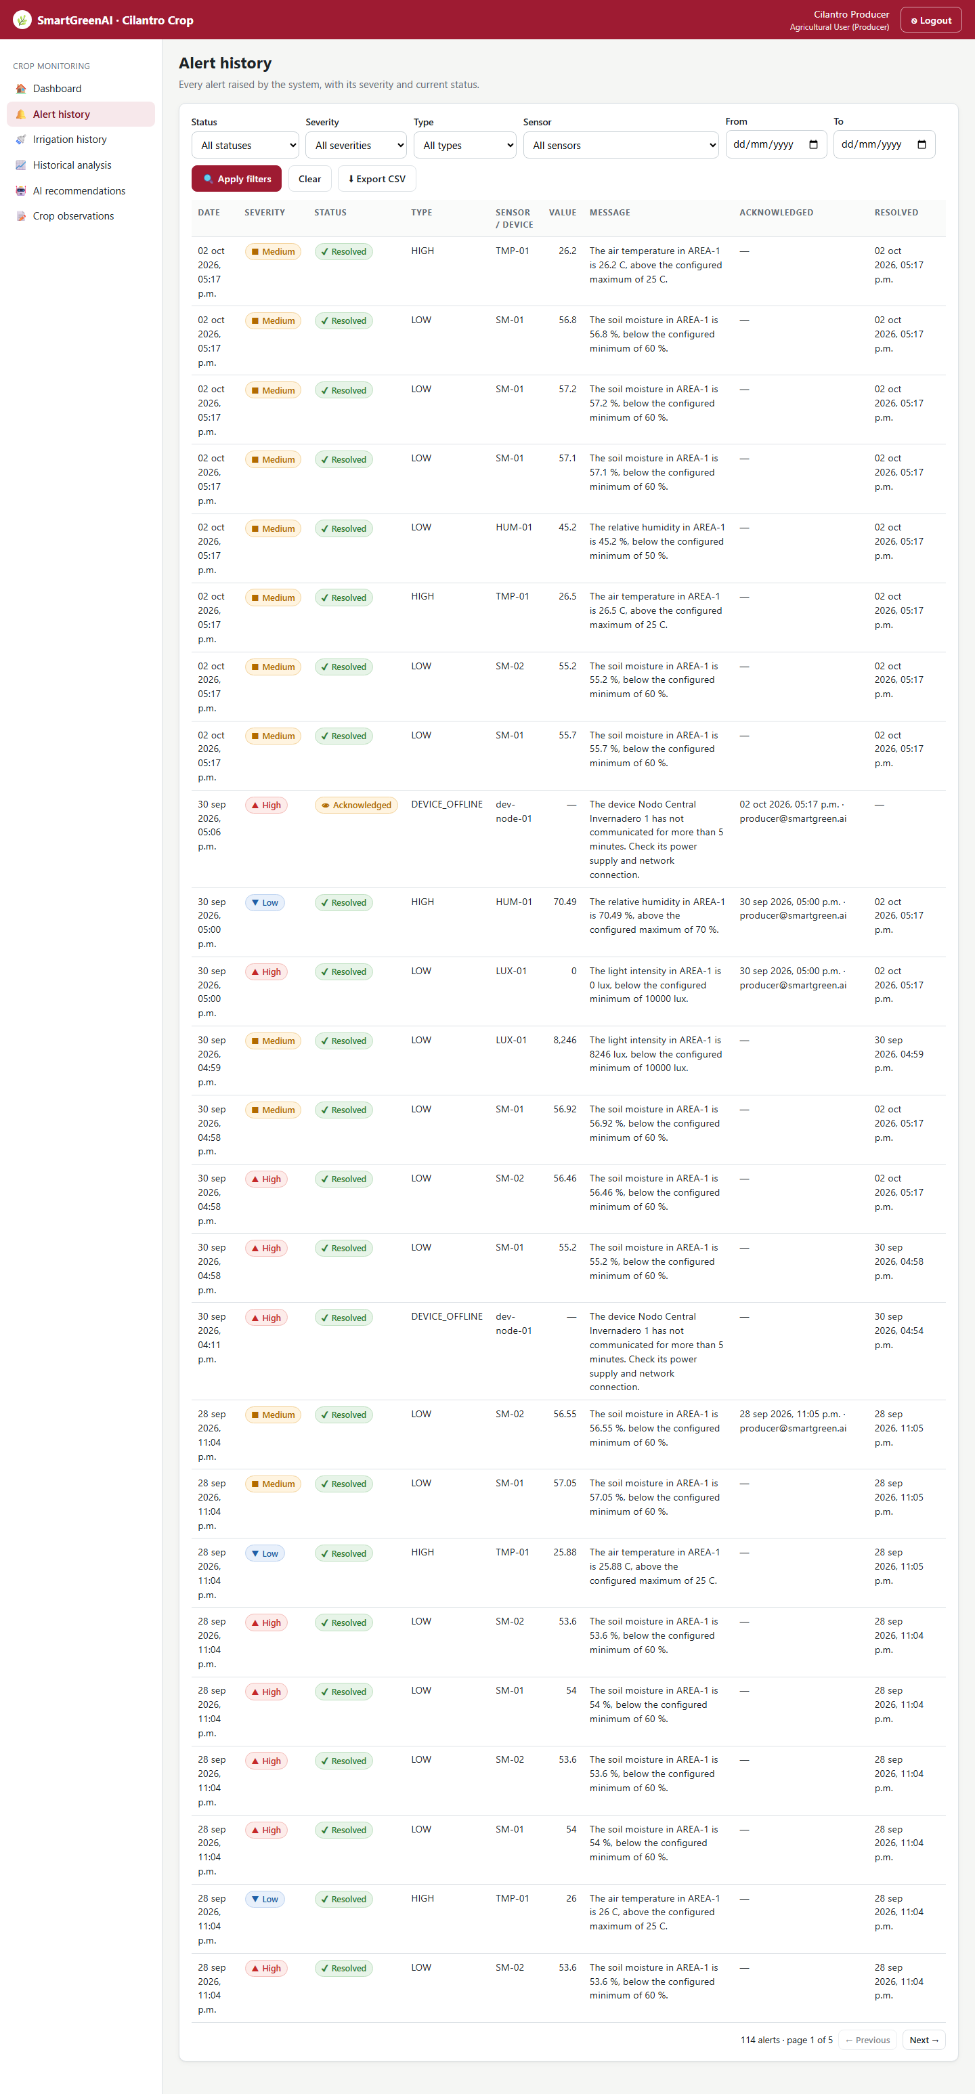
Figure US11-T7-1. Alert history after the five cases: the LOW and HIGH alerts appear as Resolved. (US11-T7_Test_Alert_Generation_1.png)
✓ Condition 2: Every case has a pass/fail result.
How it was verified: Every case has a pass/fail result (test table: 5/5 PASS). The automated alert tests of the repository were also run: Tests: 17 passed, 17 total.
Jest — thresholds and alerts suite (excerpt) (attached: US11-T7_Test_Alert_Generation_2.txt)
PASS server/tests/integration/thresholds-alerts.test.js
US-10 thresholds
√ GET /thresholds lists one row per variable of the area (110 ms)
√ admin updates a threshold; updated_by and updated_at are stored and audited (468 ms)
√ min greater than max -> 400 with details (39 ms)
√ min equal to max -> 400 with details (32 ms)
√ below the physical range of the sensor -> 400 with details (31 ms)
√ above the physical range of the sensor -> 400 with details (30 ms)
√ non-numeric values -> 400 (19 ms)
√ unknown threshold -> 404 (18 ms)
US-11 / US-12 alert engine
√ a reading below the minimum creates a LOW alert with LOW severity (10 %) (58 ms)
√ repeated out-of-range readings do not duplicate the alert; the severity is upgraded (42 ms)
√ a HIGH temperature alert above the maximum (33 ms)
√ the value returning to range resolves the alert with resolved_at (30 ms)
√ low light is normal at night: the light minimum only applies during daylight (local time) (90 ms)
√ a reading outside the physical range raises an anomaly, not a threshold alert (32 ms)
US-13 alert history
√ acknowledge an open alert records who and when; a later ack keeps the first acknowledger (56 ms)
√ filters by status, severity, sensor and date with pagination metadata (48 ms)
√ CSV export with the same filters (15 ms)
Test Suites: 1 passed, 1 total
Tests: 17 passed, 17 total
Snapshots: 0 total
Time: 4.725 s
Ran all test suites matching /server\\tests\\integration\\thresholds-alerts.test.js/i.

✓ Condition 3: Defects were fixed or registered on the board.
How it was verified: No defect was found in this execution. A defect found while building the engine (a statistical outlier suppressed real threshold alerts) was fixed before this run; see the Sprint 3 integration test (SPR-T1).
✓ Condition 4: Evidence: Test case table with results and screenshots.
How it was verified: Test case table with results and screenshots.

4. Alert generation test cases
ID | Case | Steps | Input | Expected | Actual | Result
AL-01 | Value below minimum | Send SM-01 below 60 % | SM-01 = 57 % | OPEN LOW alert | LOW MEDIUM, created true | PASS
AL-02 | Value above maximum | Send TMP-01 above 25 °C | TMP-01 = 26.2 °C | OPEN HIGH alert | HIGH MEDIUM, created true | PASS
AL-03 | Value in range | Send HUM-01 inside 50–70 % | HUM-01 = 61 % | no alert | no alert | PASS
AL-04 | Repeated out-of-range (no duplicate) | Send SM-01 below min again | SM-01 = 56.8 % | same alert, not created | id same, created false | PASS
AL-05 | Return to range (resolved) | Send SM-01 and TMP-01 back in range | SM-01 66 %, TMP-01 22.5 °C | both RESOLVED with resolved_at | RESOLVED ✓ resolved_at, RESOLVED ✓ resolved_at | PASS
Totals: 5 cases · 5 PASS · 0 FAIL

5. Attached files
- US11-T7_Test_Alert_Generation_1.png
- US11-T7_Test_Alert_Generation_2.txt

6. Traceability
Related requirements | FR-12, FR-13, FR-22
Implementation | —
Verification | integration/thresholds-alerts.test.js; acceptance steps 5–6

7. Sign-off
Role | Name | Date | Signature
Responsible | Jorge Velez Delgado | October 29, 2026
Peer reviewer | Alexis Enrique Valle Parra | October 29, 2026
Product Owner acceptance | Alexis Enrique Valle Parra | October 29, 2026
Approval record: Sprint 3 Review & Delivery (October 30, 2026): "Product Owner accepted the seven user stories: all acceptance criteria met."

